Software Requirement Specification Document

For

Digital Evidence Management System

Table of Contents
Page Numbers
- Introduction
  - Purpose
  - Intended Customers/Users
  - Product Scope
  - Outline of the document
- Overall Description
  - Product Perspective
  - Product Functions
  - User Classes
  - Design and Implementation Constraints
- Diagrams
  - UML Diagrams
  - ER Diagrams
  - DFD Diagrams
- External Interface Requirements/Screenshots
  - User Interfaces
  - Hardware Interfaces
  - Software Interfaces
  - Communication Interfaces
- Other Non-Functional Requirements
  - Performance Requirements
  - Safety Requirements
  - Security Requirements
  - Software Quality Attributes
  - Business Policies/Rules (if any)
- Testing
  - Block-Box Testing
  - White-Box Testing
- Conclusion
- References
- Acknowledgements

Page Number:01
1. Introduction
1.1 Purpose
- The purpose of this document is to present a detailed description of the Digital Evidence Management System (DEMS). This Software Requirements Specification (SRS) outlines the system’s functionality, constraints, and intended users.
- It enables organizations to store, manage, and track digital evidence in a reliable manner. The system ensures the integrity and authenticity of evidence throughout the investigation process by maintaining proper access control.
1.2 Intended Customers / Users
The intended users of the Digital Evidence Management System include:
- Law Enforcement Agencies: Use the system to securely store and manage digital evidence collected during investigations.
- Cyber Crime Units:Track, analyse, and maintain integrity of digital evidence related to cyber offenses.
- Forensic Investigators: Verify evidence authenticity and add forensic analysis reports.
- Judicial Authorities:Access evidence and audit logs in read-only mode for legal verification.
The system is primarily designed for organizations that need secure handling and management of digital evidence.

Page Number:02
1.3 Product Scope
The Digital Evidence Management System is designed to:
- Securely store digital evidence such as images, videos, documents, and logs
- Maintain chain of custody for legal validity
- Ensure evidence integrity using cryptographic hash functions
- Provide role-based access to authorized users
- Generate audit logs for every operation
The system helps prevent evidence tampering and improves transparency and accountability in digital investigations.
1.4 Outline of the Document
This document includes:
- Chapter 2:Gives clear overview of the Digital Evidence Management System
- Chapter 3:Describe the design using diagrams and models
- Chapter 4: Describes about the types of Interface Requirements
- Chapter 5:List functional and non-functional requirements
- Chapter 6:Outlines the testing approach and evaluation process

Page Number:03
2. Overall Description
2.1 Product Perspective
The Digital Evidence Management System is a standalone web-based application that interacts with a secure database and file storage system.
It consists of:
- User Interface for interaction
- Backend logic for evidence handling
- Database for metadata storage
- Secure file storage for evidence files
2.2 Product Functions
Major functions of the system include:
- User authentication and authorization
- Uploading and storing digital evidence
- Automatic hash generation for integrity verification
- Chain of custody tracking
- Viewing and verifying evidence records
- Maintaining audit logs
- Role-based access control

Page Number:04

2.3 User Classes

The system supports the following user classes:
- Admin: Manages users, roles, and system configuration.
- Investigator:Upload digital evidence, view assigned cases, and track chain of custody.
- Forensic Investigators:Verify evidence integrity, perform analysis, and add forensic reports.
- Judicial Authorities: Have read only access to view evidence records and audit logs for legal verification.
- Cyber Crime Units: Can access, analyse, and manage digital evidence related to cyber investigations.
2.4 Design and Implementation Constraints
The system operates under the following constraints:
- Must comply with digital evidence handling standards
- Must ensure data integrity and confidentiality
- Only authorized users can access the system
- Evidence files cannot be modified after upload
- Limited by server storage and processing capacity
- Uses standard web technologies and relational databases
Page Number:05
Diagrams:
3.1 UML Diagrams
Use – Case Diagrams
Module Name: User Management Module
- Allows the admin to add new users such as investigators or analysts into the system.
- Enables managing user details like updating, activating, or removing users.
- Support assigning roles (Admin, Investigator, Analyst, etc.) to control responsibilities.
- Ensures only authorized users get proper access to system features.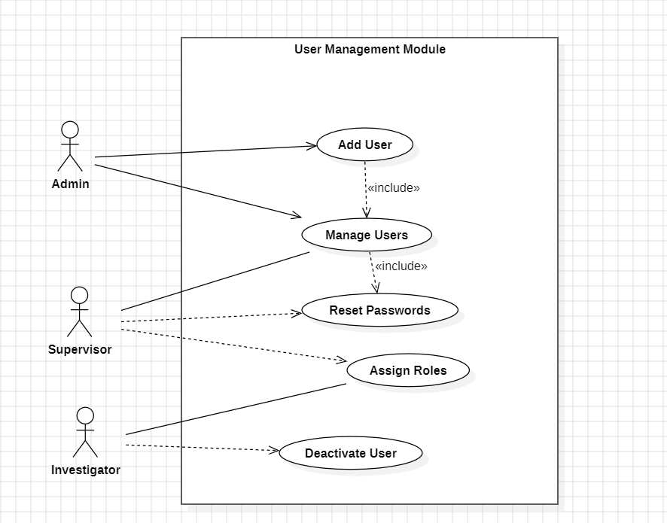

Page Number:06
Module Name:Case Management Module
This module manages investiaton cases from start to finish.
- Allows the admin to create new cases for investigations.
- Enables assigning investigators to specific cases.
- Investigators can view and update case details as the investigation progresses.
- Helps in tracking case status, progress, and related information in one place.

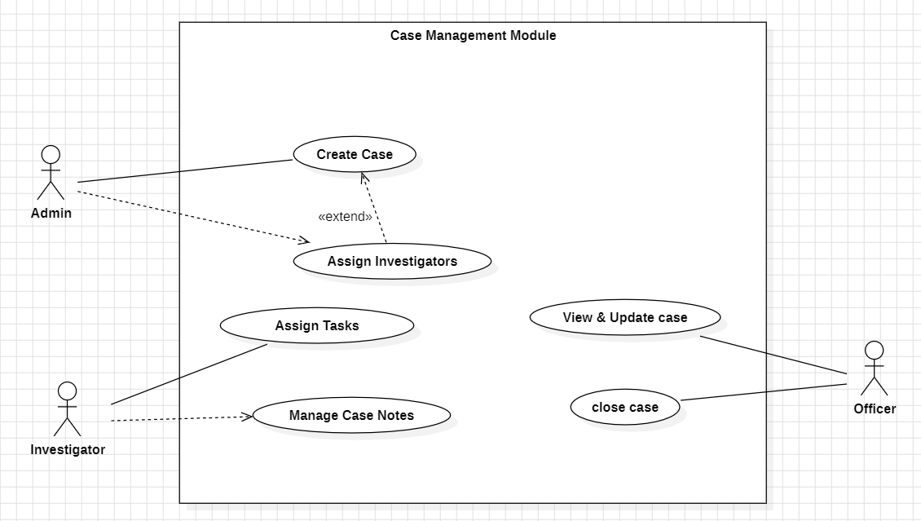

Page Number: 07
Module Name:Evidence Management Module
This module handles digital evidence securely.
- Allow investigators to upload digital evidence
- Supports tagging and classifying evidence for easy identification and search.
- Enables viewing evidence by investigators and forensic analysts.
- Ensures evidence is stored securely and linked to relevant cases.
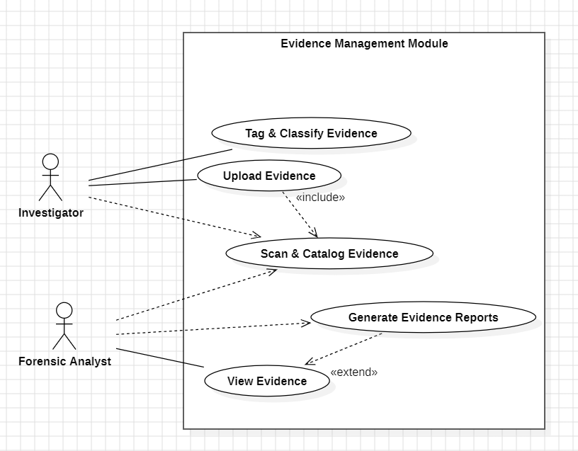

Page Number: 08
Module Name:Chain of Custody Module
This module ensures legal integrity of evidence
- Maintains a complete history of evidence handling.
- Ensures transparency and accountability in evidence movement.
- Allows admin to manage custody records properly
- Enables judges to verify evidence authenticity during legal proceedings
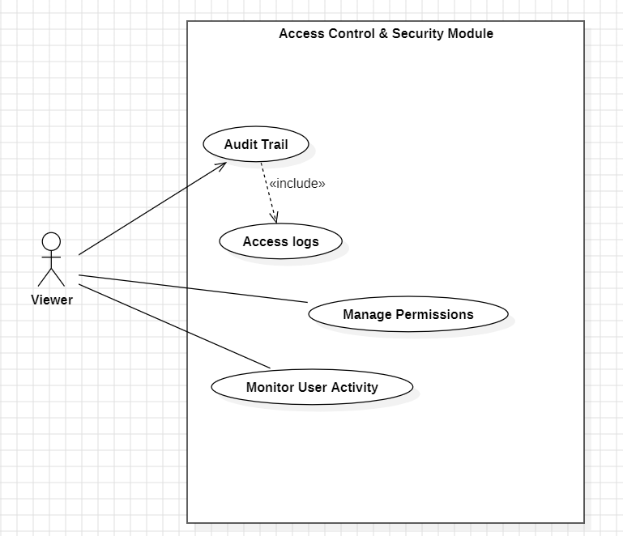

Page number:09
Module Name:Access control & security Module
This module protects the system from unauthorized access.
- Controls secure login and access for all users.
- Manages permissions based on user roles.
- Maintains an audit trail of all system activities
- Ensures system security and data confidentiality at all times
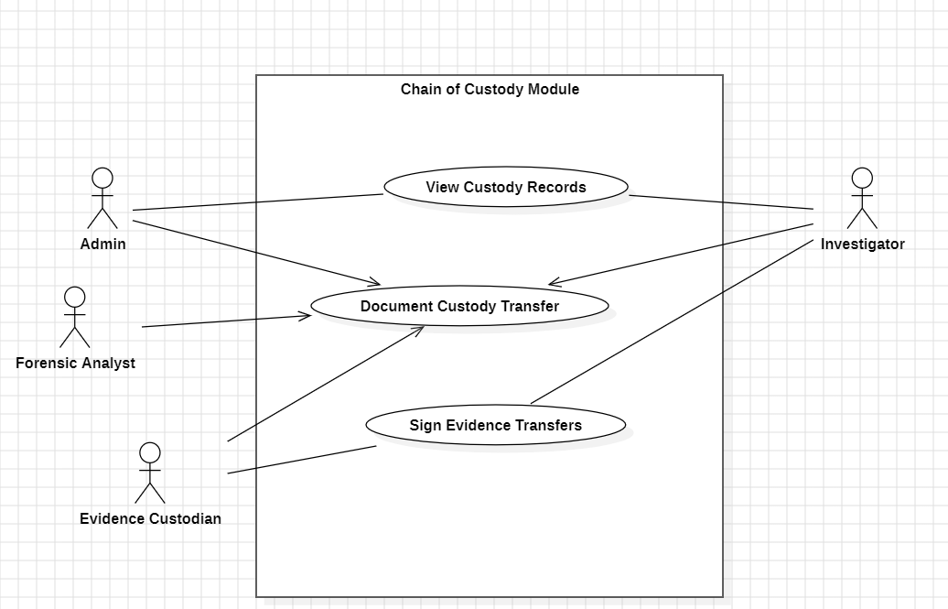

Page number: 10
Class Diagrams:
Module Name: User Management Module
- Manages all users (Admin, Supervisor, Investigator, Officer, Analyst).
- Handles user registration, login, logout, and password reset.
- Assigns roles and permissions to users.
- Allows admins to add, update, or manage user accounts.

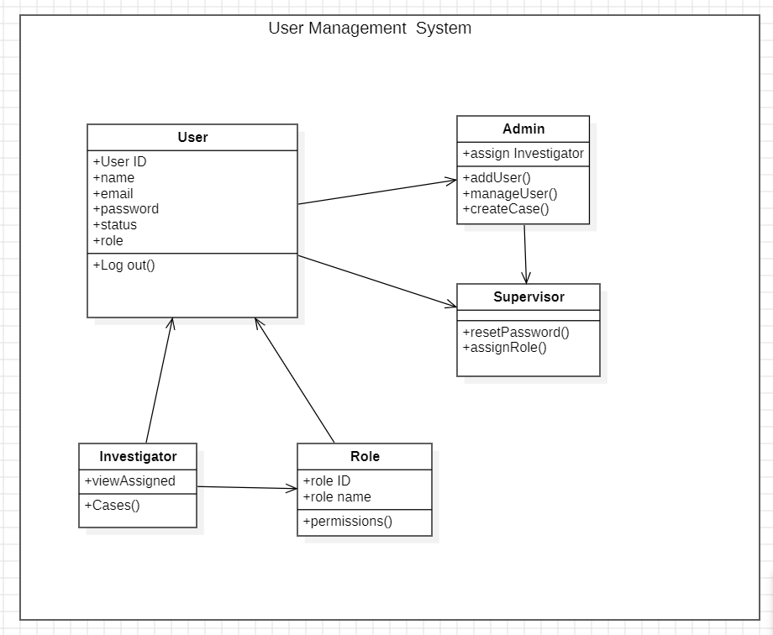

Page Number: 11
Module Name: Case Management Module
- Creates and stores criminal case details (title, description, status).
- Allows admins to assign cases to investigators.
- Enables investigators to update case progress and add notes.
- Supports closing and tracking cases over time.
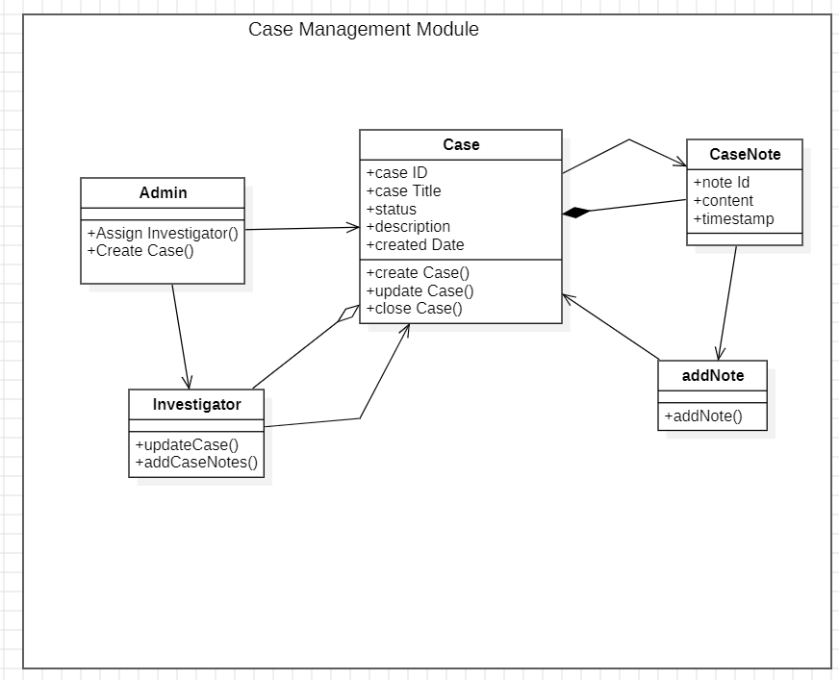

Page number: 12
Module Name: Evidence Management Module
- Handles uploading and updating of digital/physical evidence.
- Allows investigators to tag and organize evidence.
- Enables forensic and evidence analysts to analyse evidence.
- Generates evidence reports for investigations and court use.
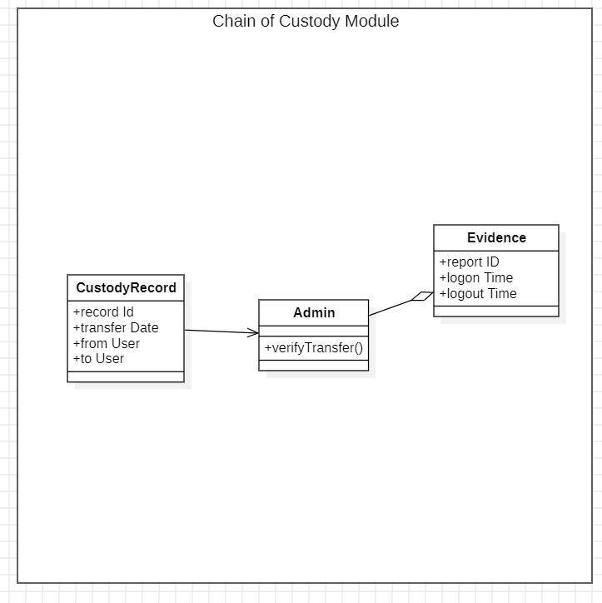

Page Number: 13
Module Name: Chain of Custody Module
- Tracks the transfer history of evidence.
- Records who transferred evidence, to whom, and when.
- Ensures evidence integrity and accountability.
- Allows admin verification of evidence transfers.
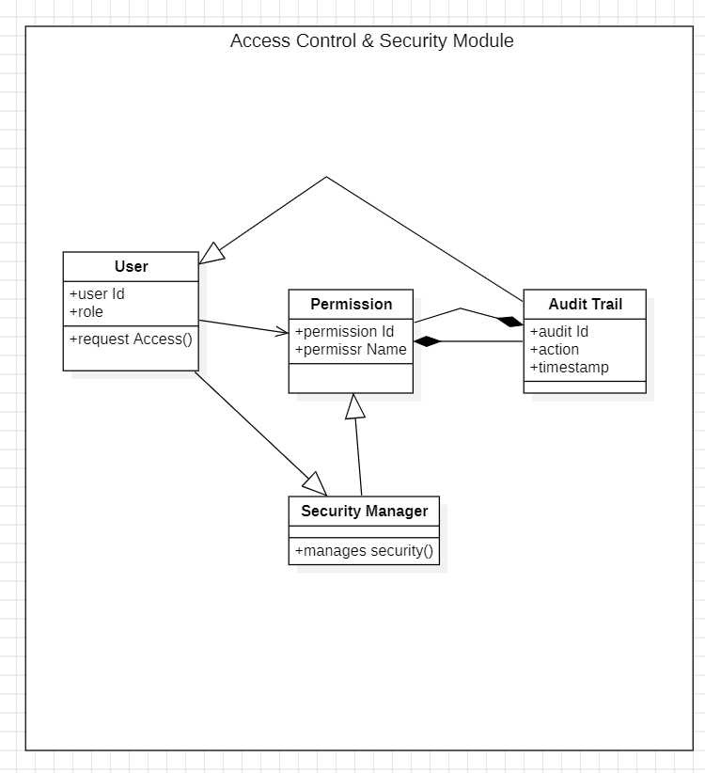

Page Number: 14
Module Name: Access Control & Security Module
- Manages user permissions and access rights.
- Ensures users only access authorized system features.
- Logs all actions in an audit trail.
- Enhances system security and compliance.
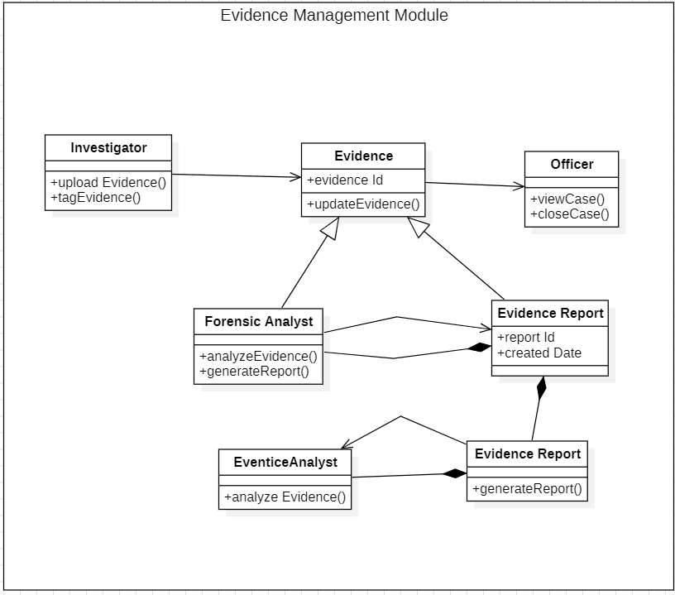

Page number:15
State Chart Diagrams:
Module using: User Management Module
Name:Admin State Chart Diagram
- Shows how an Admin logs in and manages users.
- Admin can initiate user creation and reset passwords.
- Admin assigns investigators to cases.
- Finally, all actions are logged and the process ends.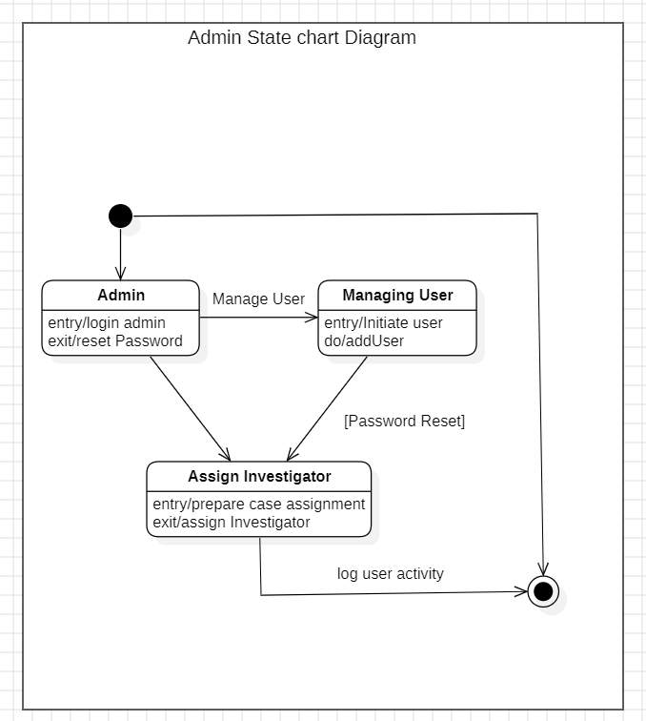
Page number:16
Name: User State Chart Diagram
- Represents a user starting with user ID and basic access.
- User can manage or add new users.
- New user data is initialized and logged.
- Process ends once the user is successfully added.
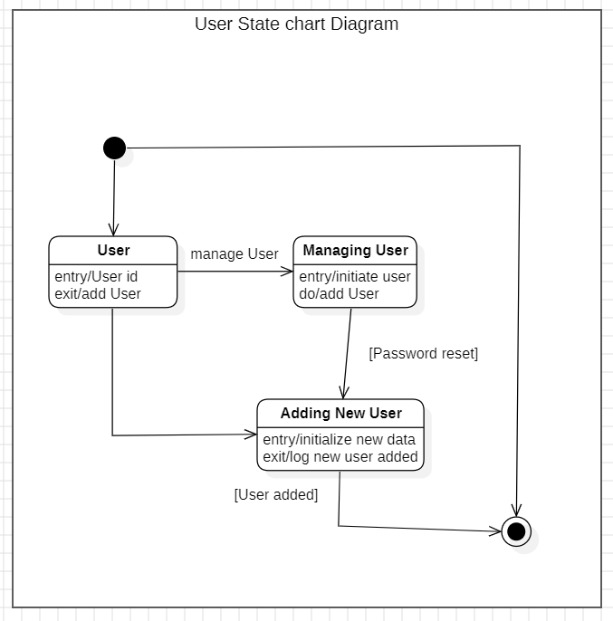

Page Number: 17
Name: Supervisor State Chart Diagram
- Supervisor begins by viewing assigned cases.
- Can access and review case details.
- Supervisor adds new cases and sets case IDs.
- Case information is saved and the session ends.
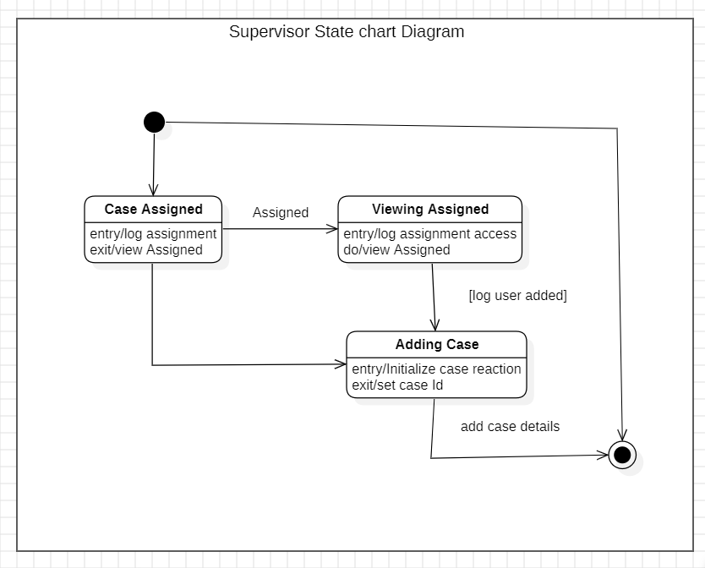

Page Number: 18
Name: Investigator State Chart Diagram
- Investigator starts by viewing assigned cases.
- Can reset and change passwords.
- Investigator assigns roles to users.
- After setting roles, the process completes.
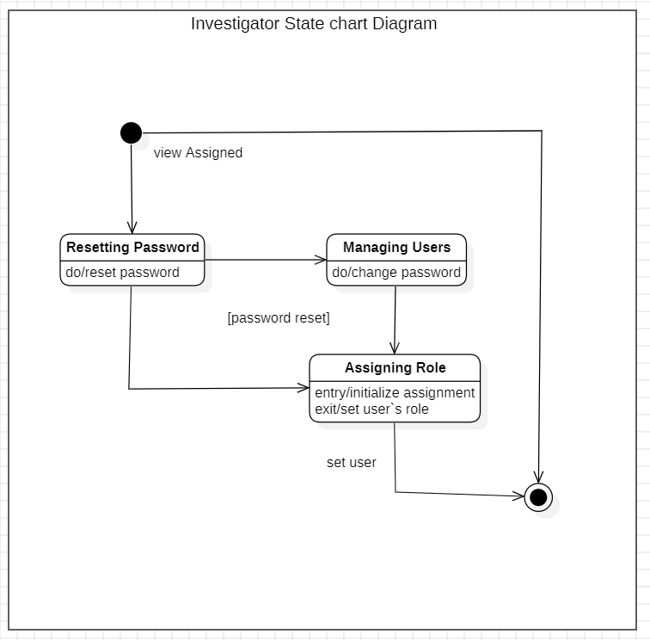

Page Number: 19
Name: Role State Chart Diagram
- Role creation starts with setting a role name.
- Role definition gives access rights.
- Permissions are assigned and logged.
- Process ends after permissions are finalized.
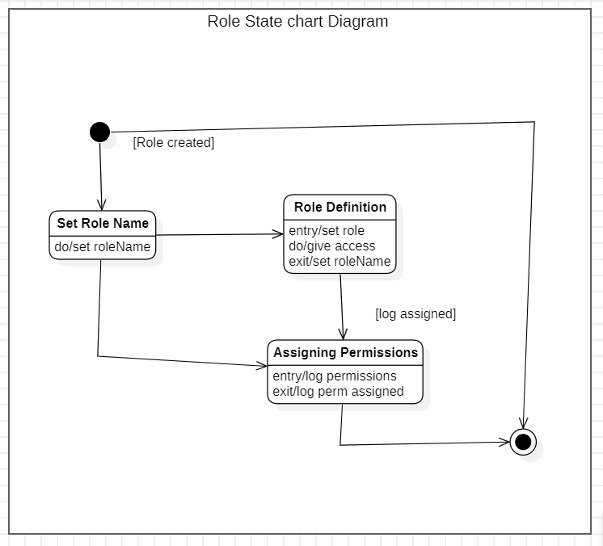

Page Number: 20
Activity Diagram:
Module: Access Control and Security Module
- The process starts when an Admin or Security Manager logs into the system.
- The system checks whether the user requests access.
- If access is requested, the system decides whether to grant permission.
- If permission is granted, access is allowed; otherwise an error is shown.
- Finally, the user logs out and the session ends.
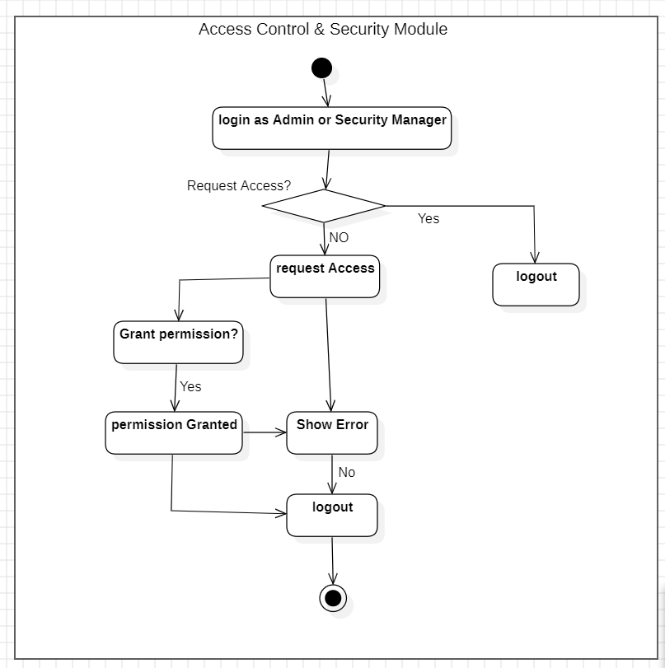

Page Number: 21
Module: User Management Module
- The system shall allow the Administrator to log in by entering valid authentication credentials. The system shall validate the entered login details before granting access.
- The system shall allow the Administrator to perform user operations including adding a new user, updating existing user information, or deleting a user account.
- After completing the selected operation, the system shall save all changes to the database and display a confirmation message indicating successful completion of the process.
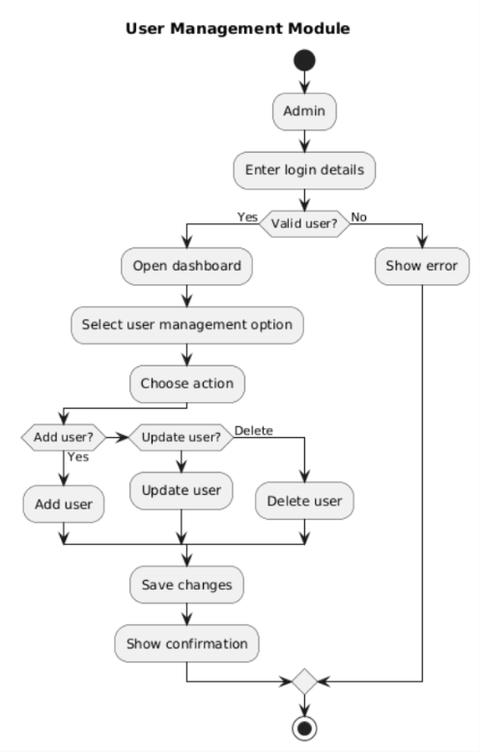
Page Number: 22
Module: Case Management Module
- The system shall allow the Administrator to log in using valid credentials. The system shall verify the credentials and restrict access if authentication fails.
- The system shall allow the Administrator to create a new case or close an existing case. When creating a case, the system shall assign an investigator and store the case details.
- After performing the selected case operation, the system shall display a confirmation message and allow the Administrator to log out, thereby terminating the session.
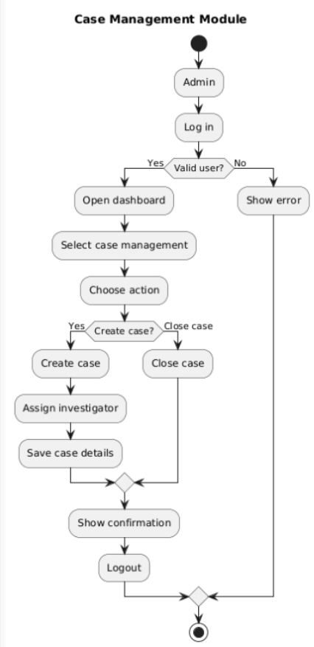
Page Number: 23
Sequence Diagram:
Module: User Management Module
- The system shall allow the Administrator to enter new user details through the user interface.
- The system shall validate the entered user information through the user controller.
- If the details are valid, the system shall store the new user record in the database.
- The system shall display a success or error message based on the validation result.
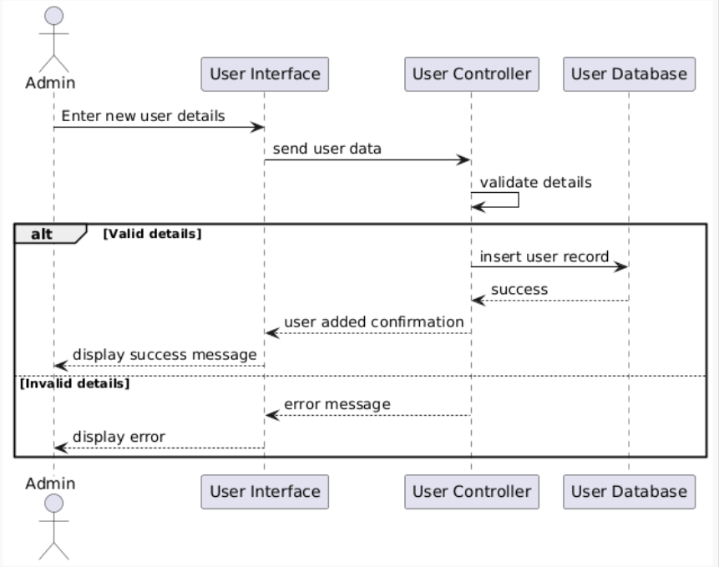

Page Number: 24
Module: Case Management Module
- The system shall allow the Administrator to enter case details through the case interface.
- The system shall validate the case information using the case controller.
- If the data is valid, the system shall create a new case and store it in the database.
- The system shall display a confirmation message or an error message accordingly.
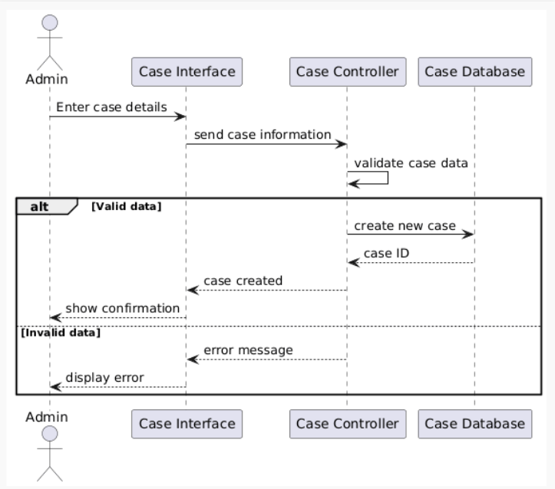
Page Number: 25
Module: Evidence Management Module
- The system shall allow the Investigator to upload an evidence file through the evidence interface.
- The system shall validate the uploaded file using the evidence controller.
- If the file is valid, the system shall store the file and save the evidence metadata in the database.
- The system shall display a success message or an error message based on the validation result.
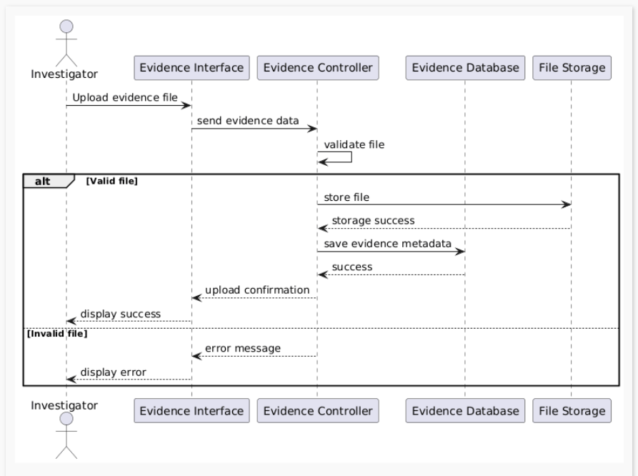

Page Number: 26
Collaboration Diagrams:
Collaboration Diagrams for following sequence diagrams using number collaboration methods
Module: User Management Module
- The Administrator enters new user details through the User Interface.
- The User Interface forwards the information to the User Controller for validation.
- Upon successful validation, the User Controller stores the new record in the User Database.
- The system sends a confirmation message to the Administrator.
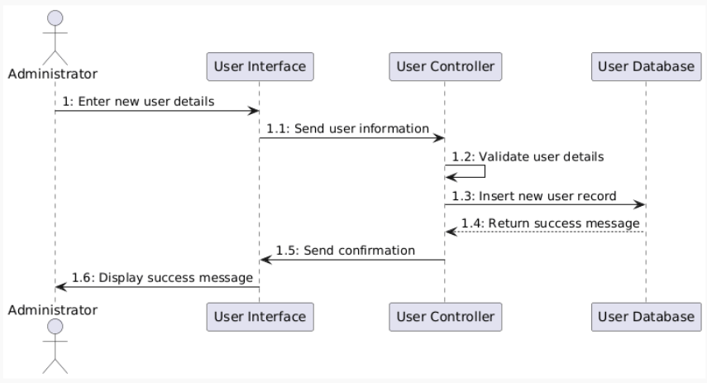
Page Number: 27
Module: Case Management Module
- The Administrator enters case details using the Case Interface.
- The Case Interface sends the data to the Case Controller for validation.
- After validation, the Case Controller creates a new record in the Case Database and generates a case ID.
- A confirmation message along with the case ID is displayed to the Administrator.
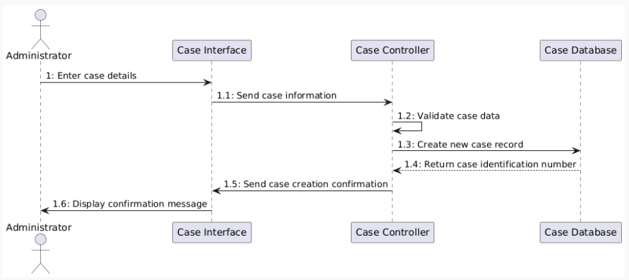

Page Number: 28
Module: Evidence Management Module
- The Investigator uploads an evidence file through the Evidence Interface.
- The Evidence Interface forwards the file to the Evidence Controller for validation.
- The validated file is stored in the File Storage System and its metadata is saved in the Evidence Database.
- The system sends an upload confirmation message to the Investigator.
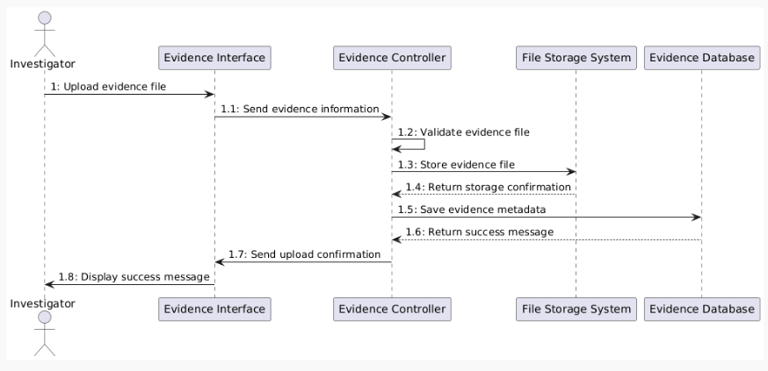

Page Number: 29
DFD Diagram:
This is the level 1 DFD diagram
- The system first authenticates the user (Investigator or Administrator) by verifying login details using the User Database.
- After successful login, the Investigator uploads digital evidence, which is validated and stored in the Evidence Database.
- The Administrator manages cases by assigning them to investigators, and case details are maintained in the Case Records.
- The system generates analysis reports, submits them for legal purposes if required, and stores final reports in the Reports Archive.
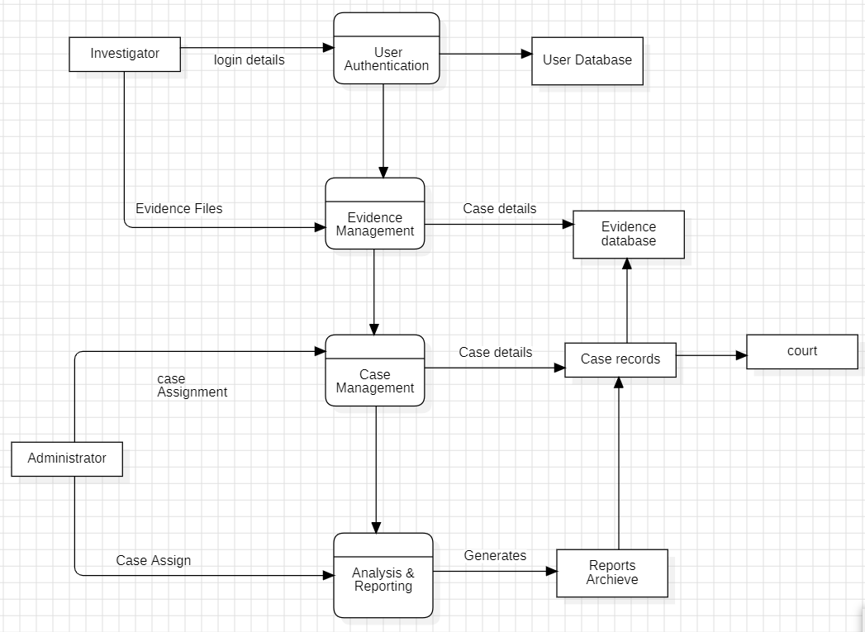
Page Number: 30
ER Diagram:
Here is the Entity-Relationship Diagram
- The USER entity represents system users, and they handle cases, upload evidence, and create audit logs within the system.
- The CASE entity stores investigation details, and each case can contain multiple pieces of evidence and generate reports.
- The EVIDENCE entity holds digital files related to a case, which are uploaded by users and linked to specific cases.
- The REPORT and AUDIT_LOG entities maintain system outputs and activity records, where reports summarize case details and audit logs track user actions.
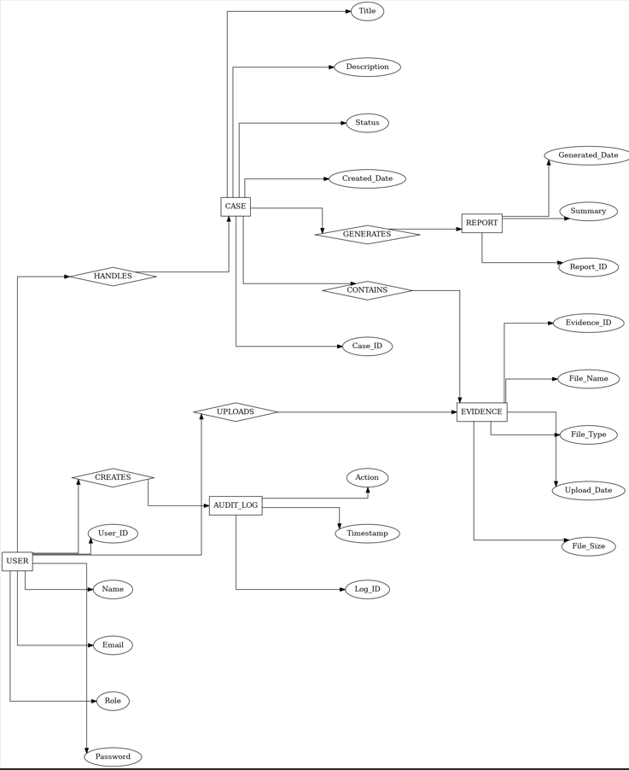
Page Number: 31
4. External Interface Requirements
4.1 User Interfaces
- The system will provide a simple login page for users to enter their credentials.
- Investigators will have a dashboard to view assigned cases and upload digital evidence.
- Administrators will have a separate interface to manage users, cases, and system settings.
- Evidence files will be displayed in a structured list with options to view, download, or analyse.
- The interface will use clear buttons, forms, and navigation menus for easy understanding.
- Error messages and success notifications will be shown to guide the user.
4.2 Hardware Interfaces
- The system will run on standard computers, laptops, or workstations.
- It will support common input devices such as keyboard and mouse.
- External storage devices like USB drives may be used for evidence collection.
- The system should work with scanners or imaging tools used for digital evidence capture.
- Minimum hardware requirements will include sufficient storage and memory to handle evidence files.

Page Number: 32
4.3 Software Interfaces
- The system will interact with a database to store user, case, and evidence data.
- It may connect with file management software for handling digital evidence.
- The application will run on common operating systems such as Windows or Linux.
- It will support standard web browsers for accessing the system interface.
- The system may integrate with reporting tools for generating investigation reports.
4.4 Communication Interfaces
- The system will use internet or local network connections for user access.
- Communication between the client and server will use standard web protocols like HTTP or HTTPS.
- Secure data transmission will be implemented to protect sensitive information.
- The system may support email notifications for important updates or alerts.
5. Other Non-Functional Requirements
5.1 Performance Requirements
- The system should respond to user requests within a few seconds.
- Evidence uploading and retrieval operations should be completed efficiently.
- The system must support multiple users accessing it at the same time.
- Database operations should be optimized to avoid delays.

Page Number: 33
5.2 Safety Requirements
- The system must prevent accidental deletion of important evidence.
- Backup mechanisms should be available to recover lost data.
- User actions should be confirmed before performing critical operations.
- System errors should not result in loss of stored information.
5.3 Security Requirements
- Users must log in with valid credentials before accessing the system.
- Different roles (admin, investigator) will have different access permissions.
- Evidence files should be protected from unauthorized access.
- All user actions must be recorded in audit logs.
- Data transmission should use secure protocols.
5.4 Software Quality Attributes
- The system should work without frequent failures.
- The interface should be simple and easy to learn.
- The software should be easy to update and fix.
- The system should handle increasing data and users.
- The system should be accessible whenever needed.
5.5 Business Policies / Rules
- Only authorized users can access case and evidence data.
- Each case must be assigned to a specific investigator.
- Evidence must be linked to a valid case before storage.
Page number: 34
6.Testing:
6.1.Blackbox Testing:
Boundary Value Analysis:
Code 1:
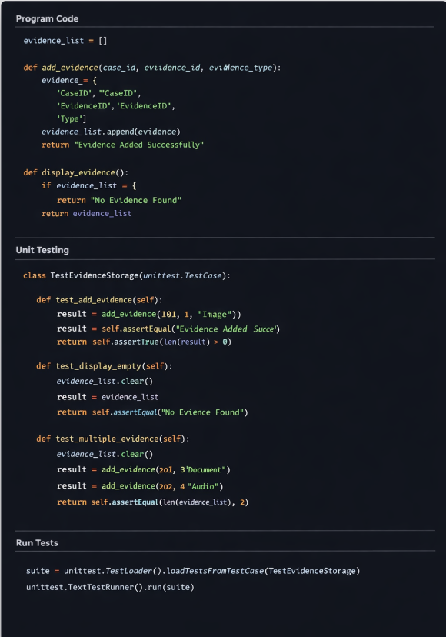

For Case ID / Evidence ID
Test Case | Input Value | Expected Result
TC1 | -1 | Invalid input
TC2 | 0 | Invalid input
TC3 | 1 | Valid evidence ID
TC4 | Large positive number | Valid evidence ID

Page number: 35
For Evidence List Size
Test Case | Condition | Expected Output
TC5 | 0 records | No Evidence Found
TC6 | 1 record | Display evidence
TC7 | Multiple records | Display evidence
Code: 2
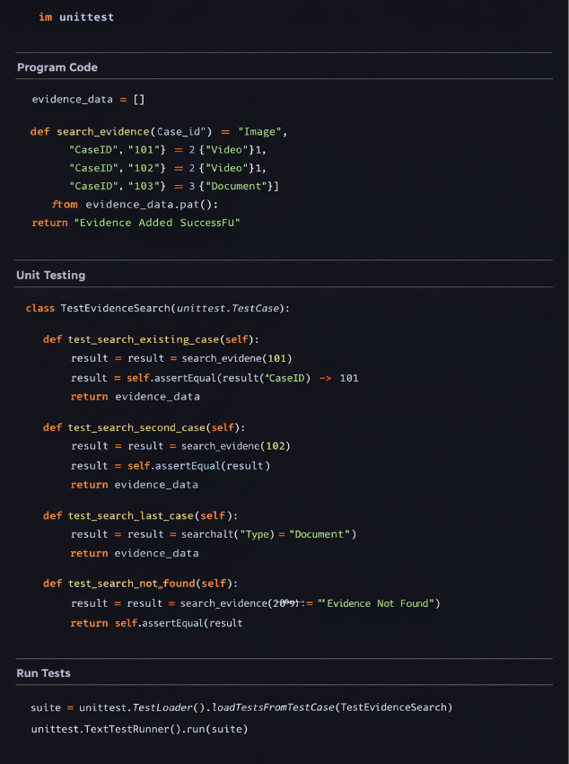

Page number: 36
For Case ID Search
Test Case | Input Value | Expected Output
TC1 | -1 | Invalid input
TC2 | 0 | Invalid input
TC3 | First Case ID in list | Evidence Found
TC4 | Last Case ID in list | Evidence Found
TC5 | Value greater than existing IDs | Evidence Not Found

For Evidence Data List
Test Case | Condition | Expected Output
TC6 | Empty list | Evidence Not Found
TC7 | One record in list | Evidence Found
TC8 | Multiple records in list | Evidence Found

Boundary Value Analysis is a black box testing technique used to test the boundary limits of input values. In the Digital Evidence Management System, it is applied to inputs such as Case ID and Evidence ID in both evidence storage and search programs. Test cases are created using values just below, at, and above the boundary conditions. This helps verify that the system correctly handles valid and invalid inputs. It ensures the program works correctly at critical input limits.

Page number: 37
6.2 Whitebox Testing:
Code: 1


Page number: 38
Flow Graph Notation:
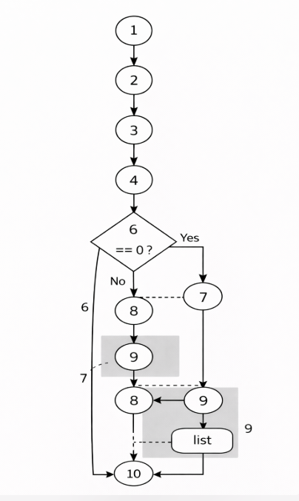
Cyclomatic Complexity Calculation
Method 1: Using Number of Regions
Total Regions = 3
- (1) {1,2,3,4-5-7-9-10}
- (2) {1,2,3,4-6-8-10}
- (3) {4}
$$V(G)=3$$
Page number: 39
Method 2: Using Edges and Nodes
Number of Nodes
$$N=10$$
Number of Edges
$$E=11$$
Formula
$$V(G)=E-N+2$$Substitute values
$$V(G)=11-10+2 \\ V(G)=3$$
Method 3: Using Predicate Nodes
Number of predicate (decision) nodes
$$P=1$$Formula
$$V(G)=P+1$$Substitute values
$$V(G)=1+1=2$$
But considering loop/branch structure, total independent paths = 3
Cyclomatic Complexity = 3

Page number: 40
Final Result
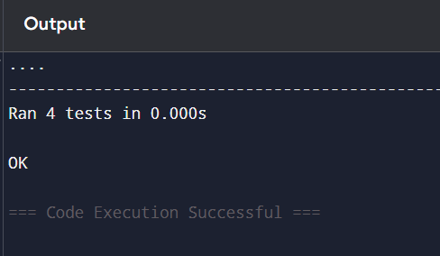
All Testcases are successfully implemented in Unit Testing.
Code: 2

Page number: 41
Flow Graph Notation:
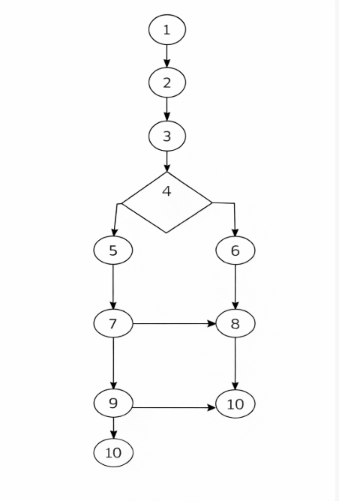
Cyclomatic Complexity Calculation
Method 1: Using Number of Regions
Total Regions = 3
- (1) {1,2,3,4-5-7-9-10}
- (2) {1,2,3,4-6-8-10}
- (3) {4}
$$V(G)=3$$

Page number: 42
Method 2: Using Edges and Nodes
Number of Nodes
$$N=10$$
Number of Edges
$$E=11$$Formula
$$V(G)=E-N+2$$Substitute values
$$V(G)=11-10+2 \\ V(G)=3$$
Method 3: Using Predicate Nodes
Number of predicate (decision) nodes
$$P=2$$(1) For loop condition
(2) If condition (case ID check)
Formula
$$V(G)=P+1$$Substitute values
$$V(G)=2+1 \\ V(G)=3$$Cyclomatic Complexity = 3
Page number: 43
Final Result
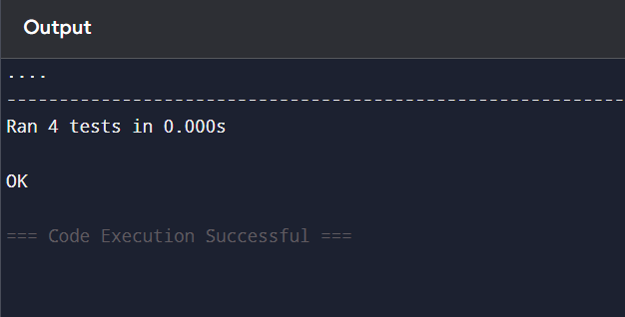
All Testcases are successfully implemented in Unit Testing.
7.Conclusion:
The Digital Evidence Management System was successfully designed and implemented to store and manage digital evidence records. The system allows adding, displaying, and searching evidence information efficiently. Different software testing techniques were applied to verify the correctness of the program. This project helped in understanding software development and testing concepts in a practical way.
8.References:
- Software engineering lab manual provided by the professor.
- Online resources and documentation related to software testing techniques.
- Geeks for Geeks, Testing concepts.

Page number: 44
9.Acknowledgement:
Iwould like to thank our Software Engineering faculty for their guidance and support in completing this project. Their instructions helped me understand the concepts and implementation clearly. I also thank my institution for providing the necessary resources to complete this work.

Page number: 45
Design Architecture
Component Level Design:
- The User Interface allows the admin or investigator to interact with the system.
- The Authentication Module checks the user login and gives access to authorized users.
- The Evidence Management Module manages uploading, storing, and handling digital evidence.
- The Search & Retrieval and Report Generation modules get data from the Evidence Database to search evidence and create reports.
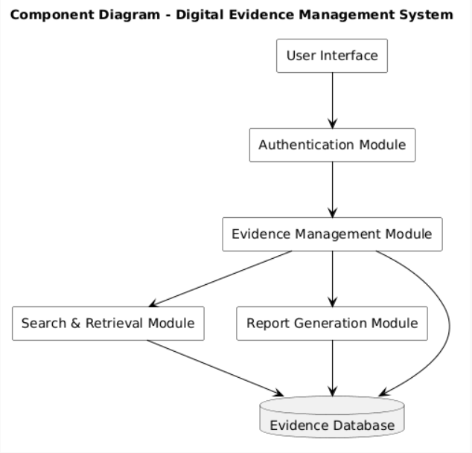

Page number: 46
Deployment Level Design:
- The Client Device (admin/investigator computer) accesses the system using a web browser.
- The Web Server provides the user interface and receives requests from the client.
- The Application Server processes the system functions like authentication, evidence management, and report generation.
- The Database Server and File Storage Server store user data, case records, and digital evidence files.
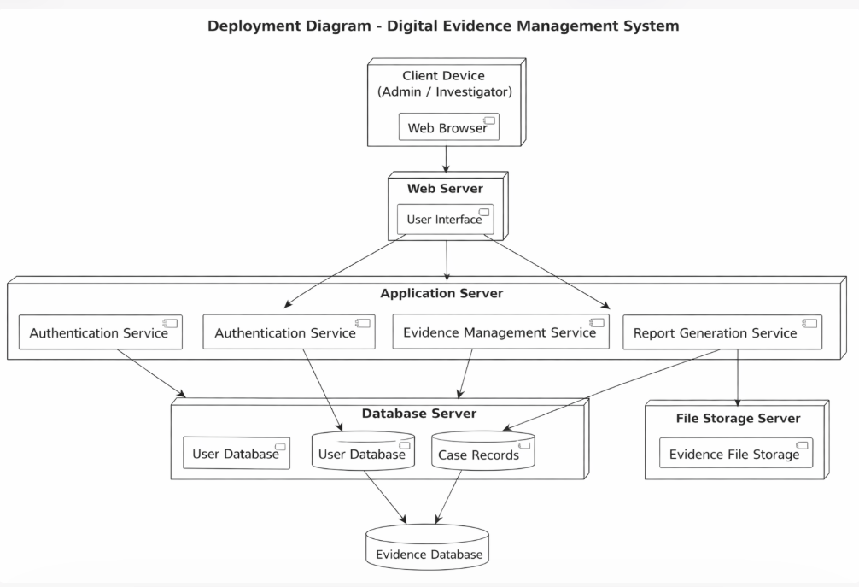

Page number: 47
Function Point Analysis
Step 1: Calculation of UFP (Unadjusted Function Points)
Identify components:
Component | Description | Count | Weight | Total
External Inputs (EI) | Upload evidence, login, register, add case, update status, assign officer | 6 | 4 | 24
External Outputs (EO) | Reports, case details, evidence reports, audit logs, notifications | 5 | 5 | 25
External Enquiries (EE) | Search case, view evidence, track case status, user query | 4 | 4 | 16
Internal Logical Files (ILF) | User data, case data, evidence data, logs | 4 | 10 | 40
External Interface Files (EIF) | Police DB, court system, cloud storage | 3 | 7 | 21
Total UFP = 24 + 25 + 16 + 40 + 21 = 126
Step 2: Calculation of CAF (Complexity Adjustment Factor)
General System Characteristics (Fi values):
4, 4, 3, 5, 4, 5, 4, 5, 4, 3, 3, 3, 4, 4
Sum of Fi:
$$\text{Sum}=55$$
Formula:
$$CAF=0.65+(0.01×\text{Sum of Fi}) \\ CAF=0.65+(0.01×55)=0.65+0.55=1.20$$

Page number: 48
Step 3: Final Function Points (FP)
$$FP=UFP×CAF \\ FP=126×1.20=151.2≈151$$Step 4: Effort Estimation
Assume:
- 1 FP = 10 hours
$$\text{Total Effort}=151×10=1510\text{ hours}$$
Step 5: Cost Estimation
Monthly Cost:
- Developers (3) = ₹90,000
- Tester = ₹25,000
- Manager = ₹40,000
Total per month = ₹1,55,000
For 3 months:
$$\text{Total Cost}=3×1,55,000=\text{₹}4,65,000$$
FINAL RESULT:
- UFP = 126
- CAF = 1.20
- FP = 151
- Effort = 1510 hours
- Total Cost = ₹4,65,000
Page number: 49
EMPERICAL ESTIMATION MODELS: COCOMO MODEL
1) BASIC COCOMO MODEL:
- For my project “DIGITAL EVIDENCE MANAGEMENT SYSTEM”, we have estimated size as 25 KLOC.
- Since the project size is less than 50 KLOC, it comes under Organic Mode of the Basic COCOMO model.
- Now we calculate Effort, Time, and Persons required to complete the project.
EFFORT = a * (KLOC)^b
⇒ EFFORT = 2.4 * (25)^1.05 = 68.64 PERSON – MONTHS
TIME = c * (EFFORT)^d
⇒ TIME = 2.5 * (68.64)^0.38 = 10.12 MONTHS
PERSONS REQUIRED = EFFORT / TIME
⇒ PERSONS REQUIRED = 68.64 / 10.12 = 6.78 ≈ 7 PERSONS
HERE ALL THE VALUES ARE TAKEN FROM THE STANDARD COCOMO TABLE
Software Project | a | b | c | d
Organic | 2.4 | 1.05 | 2.5 | 0.38
Semi Detached | 3.0 | 1.12 | 2.5 | 0.35
Embedded | 3.6 | 1.20 | 2.5 | 0.32

Page number: 50
2) INTERMEDIATE COCOMO MODEL:
In the Intermediate COCOMO model, various cost drivers such as reliability, experience, and capability are considered along with LOC to estimate effort and time.
These cost drivers are categorized as:
1) Product Attributes
These attributes are related to the software product itself.
They define how complex and reliable the system should be.
Example:
- Required software reliability
- Size of database
- Complexity of the system
2) Hardware Attributes
These attributes depend on the hardware environment in which the software runs.
They affect performance and system limitations.
Example:
- Execution time constraints
- Memory limitations
- Machine environment

Page number: 51
3) Personnel Attributes
These attributes are related to the team working on the project.
They measure the skills and experience of developers.
Example:
- Analyst capability
- Programmer skill
- Experience with tools and systems
4) Project Attributes
These attributes are related to project management and development process.
They influence how efficiently the project is completed.
Example:
- Use of software tools
- Development methods used
- Project schedule constraints
The following points specify the criteria for assigning ratings to cost drivers:
- In the Intermediate COCOMO model, effort estimation is more accurate compared to the basic model.
- These cost drivers are grouped into four main attributes: Product, Hardware, Personnel, and Project.
- Each cost driver is assigned a rating such as Very Low, Low, Normal, High, Very High, Extreme based on project requirements.
Page number: 52
Now, based on my project requirements, I am assigning ratings to the 15 cost drivers:
- HIGH
- HIGH
- HIGH
- NORMAL
- NORMAL
- LOW
- NORMAL
- HIGH
- NORMAL
- LOW
- LOW
- NORMAL
- HIGH
- NORMAL
- HIGH
NOW LET’S CALCULATE INTERMEDIATE COCOMO MODEL
EAF (Effort Adjustment Factor)
⇒ EAF ≈1.18

Page number: 53
EFFORT = a * (KLOC)^b * EAF
⇒ EFFORT = 2.4 * (25)^1.05 * 1.18
⇒ EFFORT = 68.64 * 1.18 = 81 PERSON / MONTHS
TIME = c * (EFFORT)^d
⇒ TIME = 2.5 * (81)^0.38 = 10.63 MONTHS
PERSONS REQUIRED = EFFORT / TIME
⇒ PERSONS REQUIRED = 81 / 10.63 = 7.6 ≈ 8 PERSONS
ALL THE VALUES ARE DERIVED USING STANDARD COCOMO CONSTANTS AND COST DRIVER RATINGS

---------------------------------------- THE END -----------------------------------------

